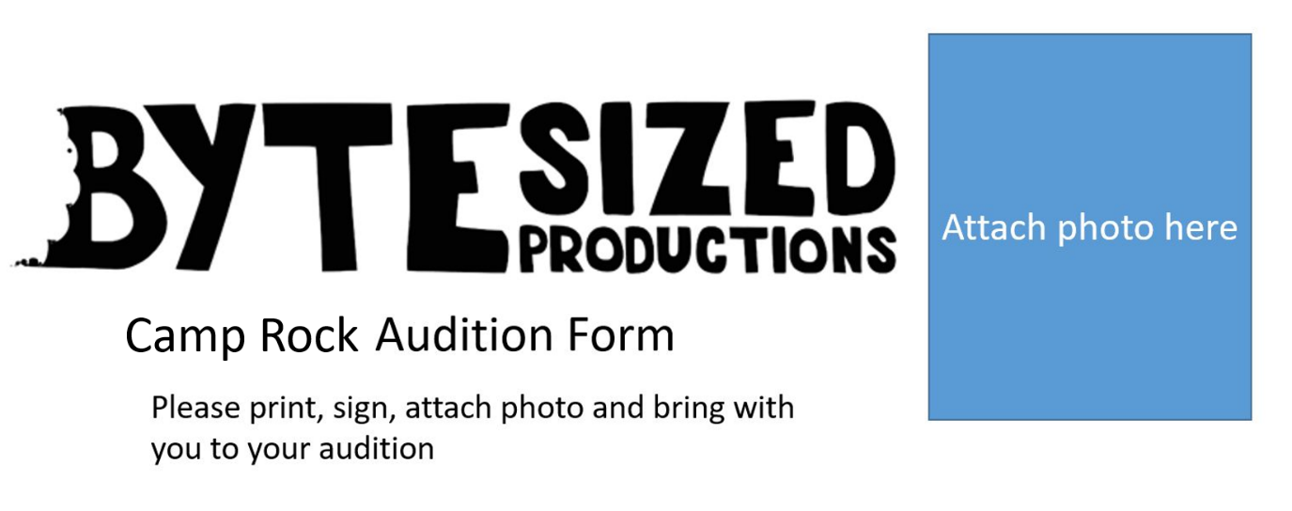

Disney Moana Jr. Audition Form Form

Name of person auditioning___________________________________________________________

Date of Birth ______________________________________________________________________

Name of parent or guardian if under 18________________________________________________

Emergency contact name and number for use during audition (please ensure this is not the auditionee’s phone number)______________________________________________________

Email of parent guardian, or auditionee if 18.

______________________________________________________________________________________

Have you been cast in, or are you auditioning for any other show in 2025, or have other commitments that may affect your availability? If so please give details. Please note, if you do not provide all details and are then unable to attend rehearsals you may be removed from the show.  
__________________________________________________________________________________________________________________________________________________________________________________________________________________________________________________________________

_____________________________________________________________________________________

Do you have any medical conditions or allergies that we need to be aware of?  
______________________________________________________________________________________

Parent/Guardian Consent  
I acknowledge that during the auditions/rehearsals/production photographs and video may be taken of participants. I understand that they will be used solely by BYTESized Productions or Albury Wodonga Theatre Company for production and promotion as they see fit. I give permission for the person named in this form to have video/photographs taken of them and used by BYTESized for production and promotion. I understand a $120 show fee will be required if my child is cast in Moana JR (discounts apply if more than one child from one family is cast).

Parent signature ______________________________________________________________________________________